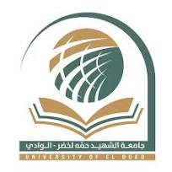

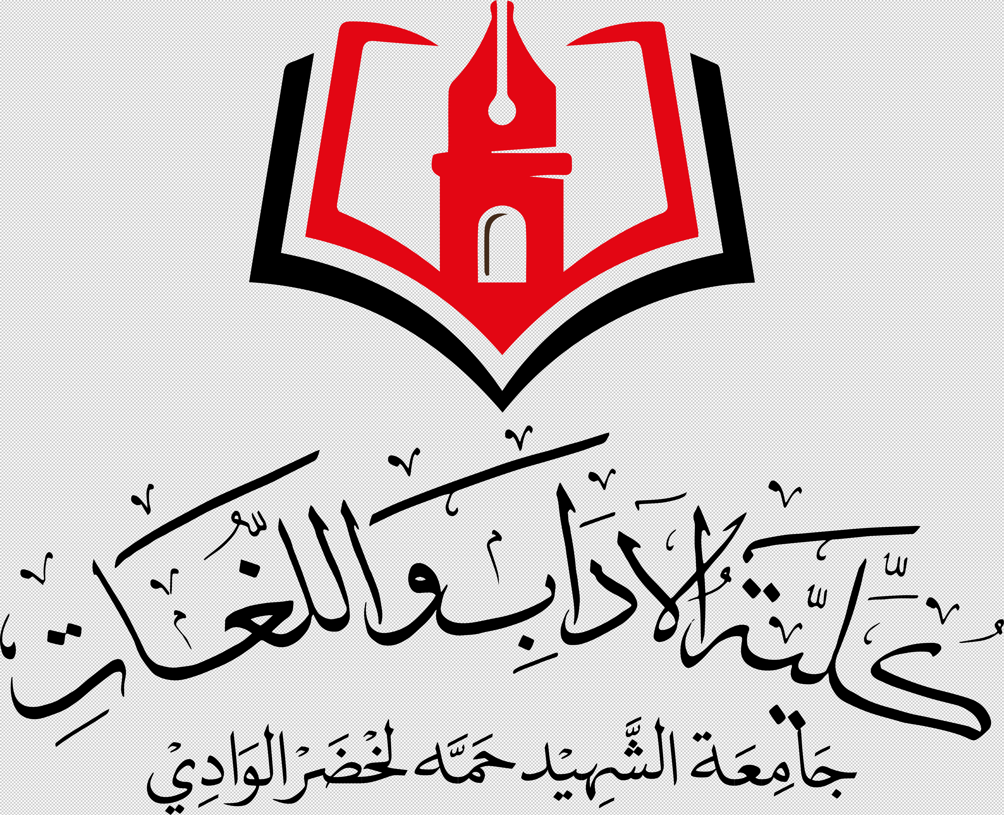

**Hamma Lakhdar University of El-Oued**

**Faculty of Arts and Languages**

**Department of Arts and English Language**

**NOTICE**

**Makeup Classes**

**Date: 21/11/2024**

M1 Students are informed that they are having makeup classes in British Civilisation as follows:

|  |  |  |  |
| --- | --- | --- | --- |
| **Group** | **Date** | **Room** | **Time** |
| **G4** | Sunday 24 Nov. | 25 | 08:00-09:30 |
| **G3** | Sunday 24 Nov. | 30 | 09:30-11:00 |

**Dr. Asma Nesba**